Launch Party
First two important steps to prepare for a launch party:
Pick a budget → Pick a launch date (2-4 weeks before the Station moves to Clear Channel)
Third and fourth steps:
Pick a location (iHeartRadio theater for smaller or Times Square for larger crowd)→ Pick a time (

- Send press packets to the invitees with details of the ‘new’ WOR,
- John Gambling and Joan Hamburg as the hosts
- Make sure Mayor Bloomberg attends, as a special guest where
- Live broadcast from the event (online and on-air) for listeners that can’t make it out

Political Panel / Q&A
WOR Teams up with Rutgers University Student Assembly (RUSA) and NJ government officials for a political panel.

- Attempt to get JOE PENNACCHI and KEVIN J. O'TOOLE (running for State Senate
PRIMARY ELECTION 06/04/2013)
- Rutgers Student Assembly elections are the beginning of April, with Presidential debates schedule for mid April. Have this event right before the debates. WOR can then track how the debates when on-air, then do follow-ups for interest listeners on how the elections turned out.
- WOR should host a political panel where the candidates from Rutgers can have a Q&A with these two candidates
- John Gambling should be the moderator for this event
- This would be a great way to get exposure before WOR moves into the building and get them on local college campuses. If this goes well, they could also go to different schools in the area with political based campus groups

NY 2013 Elections
WOR can do a political panel / Q&A with the top running candidates for the 2013 election exactly one week before election day (11/5/13) on 10/29/13. To tie-in with the panel, a topic of question could be what these officials would do in a crisis, since this date is the 1 year anniversary of Hurricane Sandy.

Interview Lounge with the Mayor
For mayor Bloomberg, they can continue with his weekly conversations but to get listeners invested there should topics that he discussed often, where listeners get the chance to call in and talk to the mayor about pressing issues. This shouldn't be taken as an opportunity for Bloomberg to market himself, but a chance for him to get to interact with the people of his city. To keep listeners informed, they can do trivia rounds with the major every other week about some New York policies, his history as mayor, etc. This trivia can be informative, but also fun to get listeners active and engaged in the segment.

Broadway VIP Lounge
For this, I had an idea that WOR could do a weekly/biweekly segment on up and coming Broadway plays. Either Joan Hamburg or Rita Cosby could do this segment. Something to look out for in this segment would how Broadway is being dominated by film stars. There are five big plays out right now that have been generating a lot of buzz that should be checked out for this!
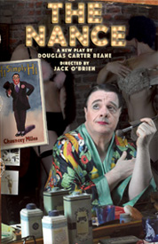 In the world of 1930’s burlesque, a nance was a wildly popular character, a stereotypically camp homosexual man, most times played by a straight performer. In The Nance, playwright Douglas Carter Beane tells the story of Chauncey Miles, a headline nance performer in New York burlesque, who also happens to be a homosexual. Integrating burlesque sketches into his drama, Beane paints, with humor and pathos, the portrait of a homosexual man, living and working in the secretive and dangerous gay world of 1930’s New York, whose outrageous antics on the burlesque stage stand in marked contrast to his messy offstage life. Starring: Nathan Lane
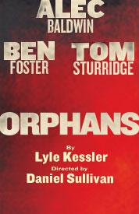 Orphans is the story of two orphaned brothers living in a decrepit North Philadelphia row house. Treat, the eldest, supports his damaged younger sibling by petty thievery, and makes the house a virtual prison for the seemingly simple-minded Phillip. One night Treat kidnaps a rich older man, Harold, who turns out to have his own motives and becomes the father figure the boys have always yearned for. Starring: Alec Baldwin, Ben Foster, and Tom Sturridge
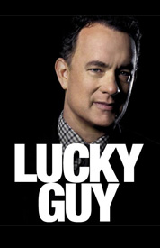 From his sensational reporting of New York’s major police corruption to the libel suit that nearly ended his career,Lucky Guy dramatizes the story of tabloid columnist Mike McAlary’s meteoric rise, fall and rise again, ending with his coverage of the Abner Louima case for which he won the Pulitzer Prize, shortly before his untimely death on Christmas Day, 1998. Starring: Tom Hanks, Peter Scolari, Christopher McDonald, Peter Gerety, and Maura Tierney
Set in the Mississippi Delta, Cat on a Hot Tin Roof is the story of Brick and his wife Maggie, who are celebrating the 65th birthday of Brick’s father, Big Daddy Pollitt. Big Daddy is bothered by the rocky relationship between his beloved son Brick, an aging football hero who has taken up drinking, and his beautiful and feisty wife Maggie. As the hot summer evening unfolds, the veneer of Southern Gentility slips away as unpleasant truths emerge. Starring: Scarlett Johansson and Benjamin Walker

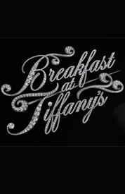 Fred is a young writer from Louisiana who meets Holly Golightly, a charming, vivacious and enigmatic good-time girl. Everyone is in love with Holly—including Fred. But Fred is competing with Holly’s other suitors: a playboy millionaire and the future president of Brazil. As the war rages on in Europe, Holly begins to fall head over heels for Fred, just as her past catches up with her. Starring: Emilia Clarke, Cory Michael Smith, and George Wendt

